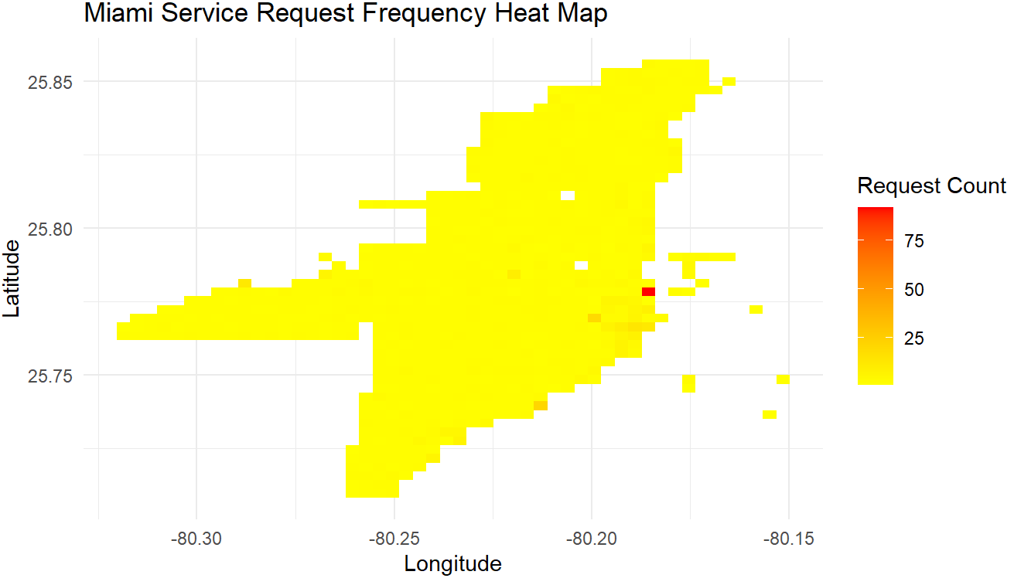
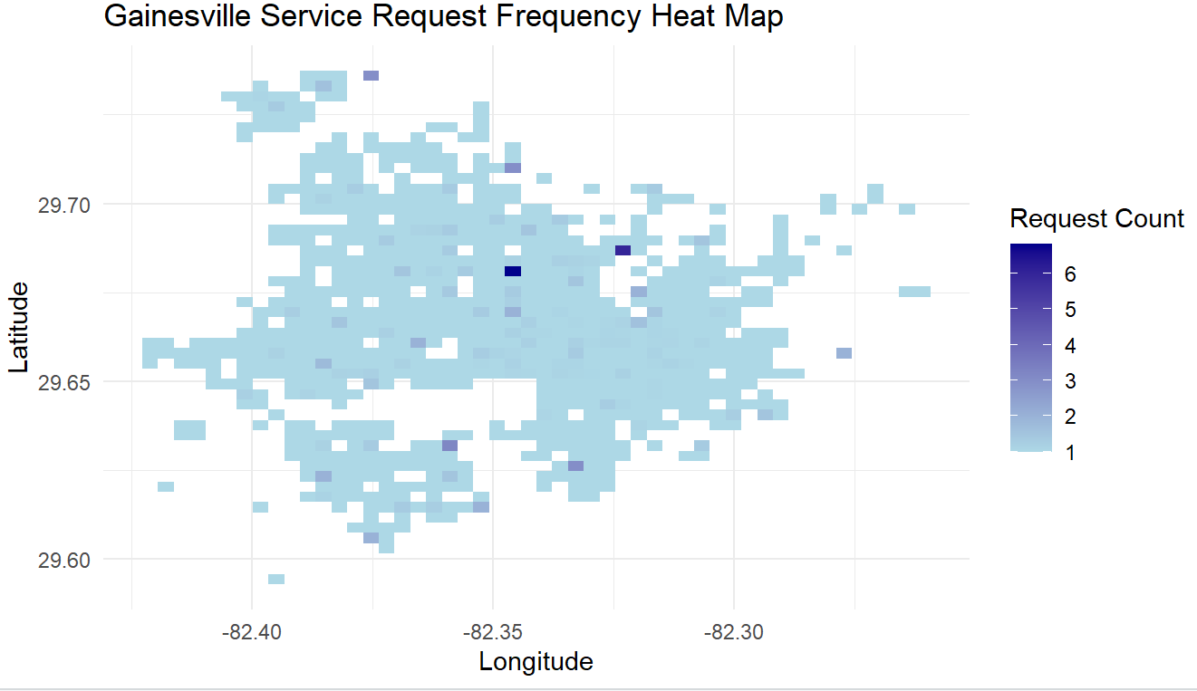

Miami Code:

library(readr)
library(dplyr)
library(ggplot2)

# load cleaned Miami dataset
miami <- read_csv("MiamiData_clean.csv")

# filter to keep only valid coordinates and count requests at each point
miami_freq <- miami %>%
filter(!is.na(latitude), !is.na(longitude)) %>%
count(latitude, longitude)

# build heat map using number of requests in each grid section
ggplot(miami_freq, aes(longitude, latitude, z = n)) +
stat_summary_2d(fun = mean, bins = 50) + # bins controls how detailed the heat map looks
scale_fill_gradient(low = "yellow", high = "red") + # yellow = few reports, red = many
labs(
title = "Miami Service Request Frequency Heat Map",
x = "Longitude",
y = "Latitude",
fill = "Request Count"
) +
theme_minimal()

Gainesville code:

library(readr)
library(dplyr)
library(ggplot2)

# load cleaned Gainesville dataset
gainesville <- read_csv("GainesvilleData_clean.csv")

# keep only rows that have latitude and longitude and count how many reports occur in each location
gainesville_freq <- gainesville %>%
filter(!is.na(latitude), !is.na(longitude)) %>%
count(latitude, longitude)

# create the heat map based on frequency of requests
ggplot(gainesville_freq, aes(longitude, latitude, z = n)) +
stat_summary_2d(fun = mean, bins = 50) + # convert the data into a grid and color by frequency
scale_fill_gradient(low = "lightblue", high = "darkblue") + # light = few requests, dark = more
labs(
title = "Gainesville Service Request Frequency Heat Map",
x = "Longitude",
y = "Latitude",
fill = "Request Count"
) +
theme_minimal()

